History, Philosophy, and Major Distributions of Linux

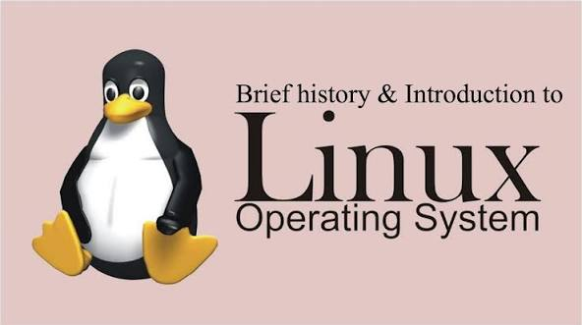

1. Introduction to Linux

What is Linux?
At its core, Linux is an operating system kernel. The kernel is the lowest level of software that interfaces directly with your computer's hardware (CPU, RAM, devices). However, when people say "Linux," they are usually referring to the complete Operating System, which includes the kernel, system libraries, and user tools.
Key Characteristics:
- Open Source: The source code is free for anyone to view, modify, and distribute.
- Multi-user & Multi-tasking: Multiple users can access system resources simultaneously, and the system can run multiple applications at once.
- Portability: It runs on almost any hardware, from supercomputers and web servers to smartphones (Android is Linux-based) and embedded IoT devices.

2. Linux History and Philosophy

The History:
- 1991: Created by Linus Torvalds, a student at the University of Helsinki. He wanted a free, open-source alternative to Minix (an educational Unix-like OS).
- Evolution: It started as a hobby project but quickly gained traction because developers worldwide began contributing code over the internet.
The Philosophy (The Unix Philosophy):
Linux adopts the design philosophy of Unix, which focuses on modularity and minimalism:
- "Do one thing and do it well": Programs should be small and specialized.
- "Everything is a file": Hardware devices, processes, and data structures are all accessed as files.
- Chaining: Small programs can be combined (piped) to perform complex tasks.
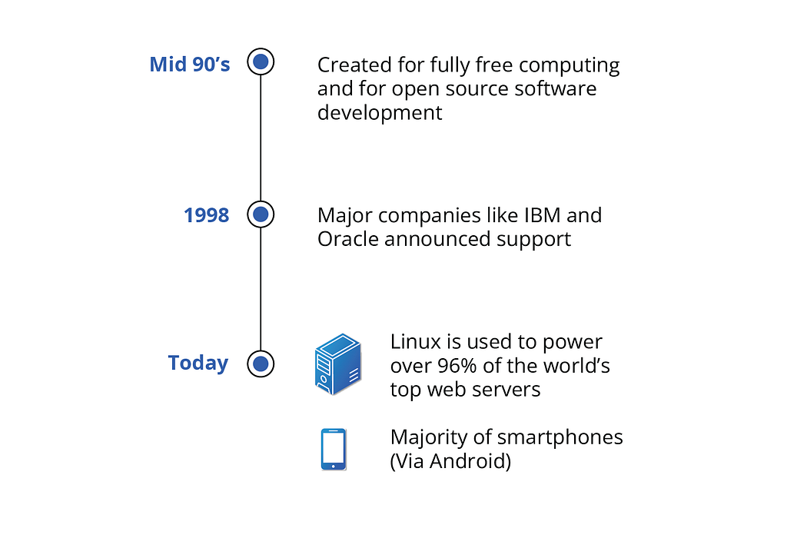

3. Origins of Linux & GNU/Linux

There is often confusion between "Linux" and "GNU/Linux." This distinction is historically significant.
- The GNU Project (1983): Started by Richard Stallman. The goal was to create a completely free Unix-like operating system. By the early 90s, they had created most of the necessary tools (compilers, text editors, shell), but they lacked a working kernel.
- The Marriage: When Linus Torvalds released the Linux kernel in 1991, it filled the final gap in the GNU system.
- The Result: The complete OS is technically GNU/Linux (GNU tools + Linux Kernel), though most people simply call it "Linux."

4. Overview of Ubuntu, Fedora, CentOS

Since Linux is open-source, anyone can bundle the kernel with different software packages. These bundles are called Distributions (Distros).
Distribution | Base / Family | Target Audience & Features
Ubuntu | Debian-based | Most Popular. Known for user-friendliness. Great for beginners and developers. Uses the apt package manager. It has a massive community and support.
Fedora | Red Hat (Upstream) | Innovation focused. It serves as the testing ground for Red Hat Enterprise Linux (RHEL). It uses the latest software versions and the dnf package manager. Ideal for developers who want the "bleeding edge" technology.
CentOS | Red Hat (Clone) | Server focused. Historically, it was a free, exact clone of RHEL, known for extreme stability. It is widely used in enterprise server environments. Note: It has recently shifted to "CentOS Stream," which is a rolling-release version.

- Commands Of Linux
Commands | Descriptions
pwd | Print working Directory
ls | Show the List of Directory
ls la | Show the List of Directory with hidden files
clear | Clear the terminal
mkdir “folder name” | To create a directory
cd | Change Directory
touch | Create an Empty File
echo "Hello linux" > file1.txt | Writes the text "Hello linux" into file1.txt.
cat file1.txt | Concatenate and Display File Content
cp file1.txt file1_backup.txt | Used to copy files or directories from one location to another
mv file2.txt notes.txt | Used to move or rename files and directories in Linux
rm “file name” | To delete any file
echo "Linux is a powerful OS" >> file1.txt | Used to append (add) text to the end of a file without deleting the existing content
grep "Linux" file1.txt | Used to search for a specific word or pattern inside files or output.
grep i "linux" file1.txt | The i option makes grep ignore case sensitivity.
grep linux * | This command searches for the word linux in all files of the current directory.
find . name "*.txt" | The find command is used to search files and directories based on conditions like name, type, size, etc.
find . type f size +0c | This command finds all nonempty files in the current directory and its subdirectories.
ps | To show Running the process
top | To show real time process
jobs | Displays all background jobs running in the current shell.
ip a | Displays network interface details in Linux.
Ipconfig | Displays network configuration in Windows.
ping google.com | The ping command is used to check network connectivity between your system and another host
df -h | The df command shows disk space usage of file systems.
du -sh . | The du command shows disk usage of files/directories.
uname -a | The uname command displays system information.
cat /etc/os-release | Displays operating system information.
whoami | Shows the currently logged-in user.

Operator | Action
> | Overwrites existing file content
>> | Appends content without deleting

